7COM1015 Unit 21 Exercises
- Look up the Java Documentation for JFrame, JButton, JLabel , JTextfield
- Write a class to display the GUI below
  - The two buttons should show/hide "Happy Christmas"
  - The Carols menu should display in the texfield:
    - Hark the herald angels sing
    - Oh come all ye faithful
    - Away in a manger
depending on the menu item chosen
- The Presents menu should have three items : book, bottle, game and when selected should display in the textfield (or another one): "You will get…." followed by the name of an actual book/alcohol or game
- All components should work as expected

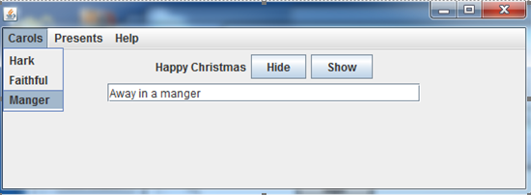

- If you wanted to display the words of the whole carol, the textfield would not be big enough. Investigate JTextArea instead of JTextField and add a JScrollPane or JScrollBar

